**Perform Detailed Design Hand-off**

**Module Description**

In this module, your team is given a set of detailed design documents (which include pseudo code) to review. As a team, you will also decide who will work on coding which classes.

**Scenario**

Your team has completed their reviews of the analysis and high level design deliverables. The Developer SMEs have completed several detailed designs. The Team Lead will review and (with assistance from you) assign team members to implement each of the detailed design components.

You and the rest of your team members will meet to discuss the detailed design documents and some questions may arise. The Developer SME working on the modules created for your team has been very busy working on other client tasks so the Development Team Manager (DTM) will look to provide answers where possible to help your team to move forward.

**ADM Activity Context Diagram**

* Application > 4100 Build Application > 4155 Perform Detailed Design

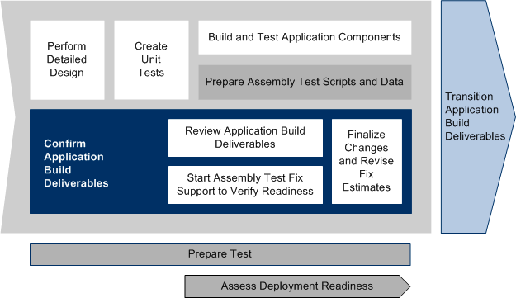

**Roles**

|  |  |  |  |
| --- | --- | --- | --- |
| **Role** | **ADM Task** | **ADM Responsibility** | **Description** |
| Team Lead | 4155 - Perform Detailed Design | Primary Performer | Assigns detailed design coding and test documentation creation responsibilities to team members. |
| Developer | 4155 - Perform Detailed Design | Primary Performer | Reviews the detailed design to prepare for coding and testing activities. |
| Manager | 4155 - Perform Detailed Design | Management Oversight | Provides guidance on the detailed designs to the team (as needed). |

**Participant Instructions**

1. Review the Class Designs (or detailed designs) in the [AP333 Component/Class Design (with pseudo code)](https://accenture.desire2learn.com/content/enforced/9406-Pending/NCCC_Project_Work_Products/3b_App_Design/Release_1/CompClsDes_FERS_R1_WPC_REF.docx?_&d2lSessionVal=YnoL4daZGC8ne2RyGf0cWMrk8) to see which ones you feel confident that you can complete. Add unanswered questions to the Query Log you began in the previous module.

Focus in particular on the following classes and class methods (and the documented complexity of each class listed in parentheses):

* EventServiceImpl.java (SIMPLE)
  + checkEventsofVisitor()
  + getAllEvents()
  + updateEventDeletions()
* EventDAO.java(MEDIUM)
  + showAllEvents()
  + updateEventDeletions()
  + checkEventsofVisitor()
* VisitorServiceImpl.java(SIMPLE)
  + createVisitor()
  + searchVisitor()
  + registerVisitor()
  + showRegisteredEvents()
* VisitorDAO.java(COMPLEX)
  + insertData()
  + searchUser()
  + registerVisitortoEvent()
  + resisteredEvents()

2. **Team Lead Only:** Review the detailed designs and consider to whom on your team you should assign the design.

3. As a team, discuss the detailed designs and decide how to divide the work amongst the team.

4. **Team Lead Only:** Based on your review and the recommendation of the team, assign the detailed designs for unit test development and coding to each team member.

5. A Manager may come to your workspace to see how your team is progressing. This is an opportunity to get answers to any questions that you have.

6. Start thinking about the best way to implement the detailed design (i.e., code the logic) and how to define the unit tests that will be used to test your code.

Make sure the work is split up so that:

* The team members more comfortable with Java code will create the more complex classes and test scripts.
* The team members less comfortable with Java code will code the simpler classes and test scripts, and create the unit test documentation.

**Hints and Tips**

* When reviewing the detailed design, ask the following questions:
  + Is the pseudo code consistent with the class design? (Attributes, methods, etc.)
  + Is error handling specified when appropriate and consistent with the Application Design?
  + Is the pseudo code supported by the other work products of the Application Design?
* Prioritize your questions. There may not be enough time to get all your questions answered. The Manager has to answer questions for a number of teams and return to their own work as well.
* **Team Lead only:** When reviewing the detailed designs, keep in mind the complexity of the design. This will help you determine who on your team should be assigned the design.